Activity 1
The View from There

In the animation “Is That Star Really There?” (www.youtube.com/watch?v=F2VOMnVyY1s), Alice and Bob propose the idea that an alien looking at Earth today might see dinosaurs. This activity builds on this intriguing idea.
Imagine that you and your partner are located on (or near) the astronomical object assigned to you, and that you have a telescope that allows you to observe light from Earth. The light that you observe would have left Earth a long time ago, so the Earth that you see would be very old, depending on how far away you are.
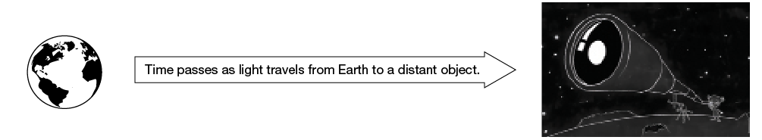

- Use the Internet to learn about the object assigned to you. Record your sources.
- What is your object?
- How far from Earth is the object?
- Where would you find the object in the sky?
- What are some interesting features of this object?

- Use the Internet to research what Earth would have looked like when the light that you receive at your location left Earth. Record your sources.
- What did Earth look like?
- Were humans around yet? What were they doing?
- What was the climate like?
- What plants and animals were dominant?

- Present your results by making two posters or electronic presentations (e.g., PowerPoint): one describes your astronomical object, and the other describes Earth as seen from your astronomical object.

